**Abstract-** Air pollution affects our day to day activities and quality of life. It poses a threat to the ecosystem and the quality of life on the planet. The dire need to monitor air quality is very glaring, owing to increased industrial activities over the past years.

People need to know the extent to which their activities affect air quality. This project proposes an air pollution monitoring system. The system was developed using the Raspberry pi. The air pollution monitoring system was designed to monitor and analyse air quality of Varanasi in real-time and log data to a remote server, keeping the data updated over the internet. The air quality measurements taken by the designed system was accurate. The result was displayed on LED Board through BX-5U3 LED Module Controller Card.

**Keywords-** Temperature, Humidity, Wind speed, Wind Direction, AQI, PM2.5, Primary Pollutant, NO2 O3, API, Weather Station.

**Contents**

Introduction …………..

Structure ……………

Hardware …………….

API ……………

Programming ……………..

Python ………………

GPIO ……………….

JAVA ………………

Shell Script ………………

Crontab ………………..

Display Interfacing ………………

Introduction:

This project monitor air quality and weather data of Ardhali Bazar, vranasi. All data received via API <https://airpollutionapi.com/> and display on LED board.

Hardware requirement:

1. Raspberry Pi
2. BX5U3 LED Controller
3. LED Display Board (192x128)
4. Jiofi
5. Red LED, Yellow LED, Green LED
6. 3 resistors 300 ohms
7. Connecting Wires

Structure:

API :

Generation of API Key –

1. Go to the link <https://airpollutionapi.com/api> .

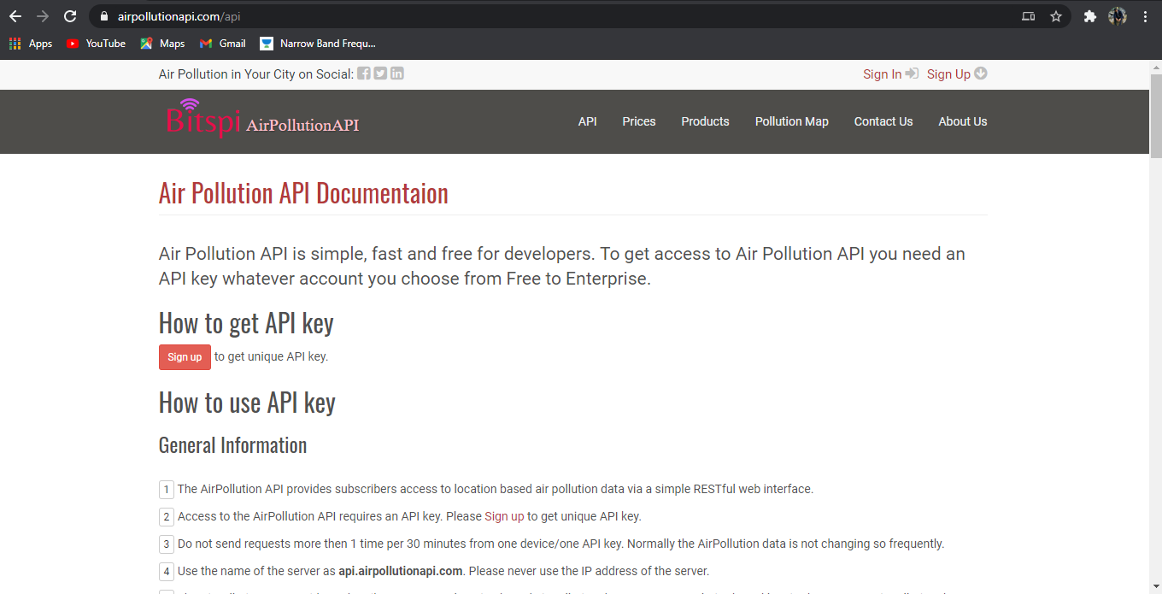

1. Go to the sign-up page and create account.

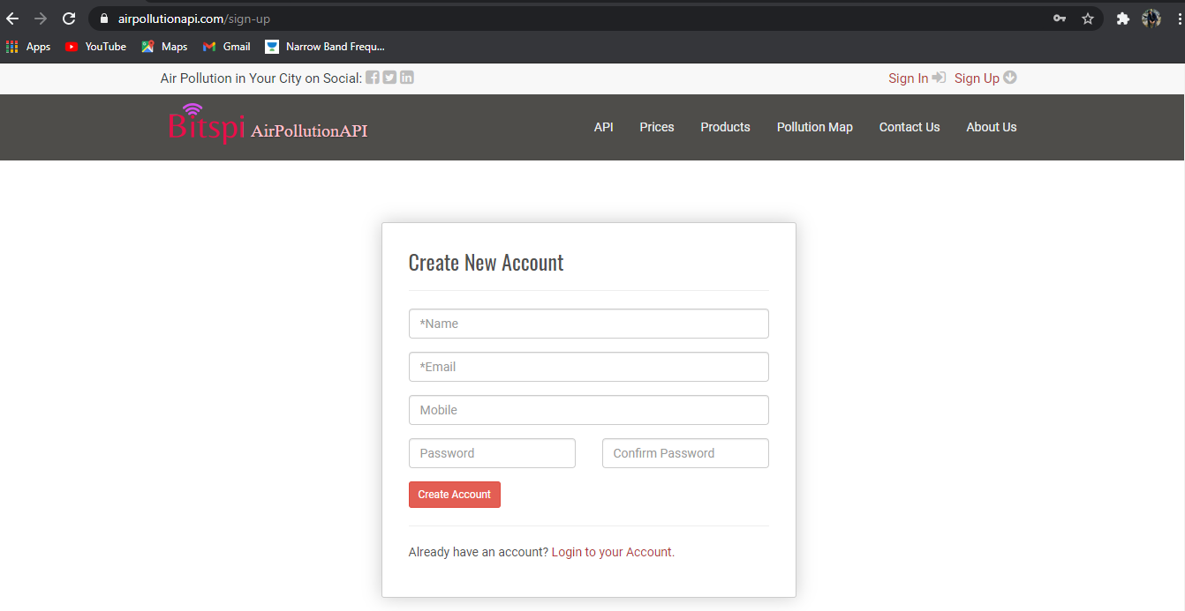

1. After creating account go to login page and login to account. After login into account in *Dashboard* section, go to *API Keys and Usage* section.

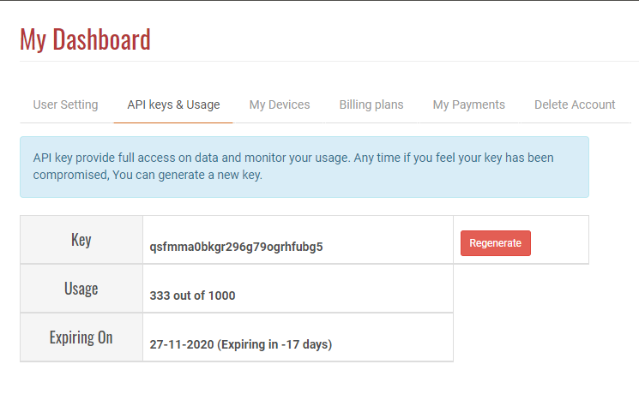

Process of using API Key:

Go to the given link for all details of the process of using API key.

<https://airpollutionapi.com/api>

Example of calling API: <http://api.airpollutionapi.com/1.0/aqi?lat=28.7040590&lon=77.10249&APPID=1111111111>

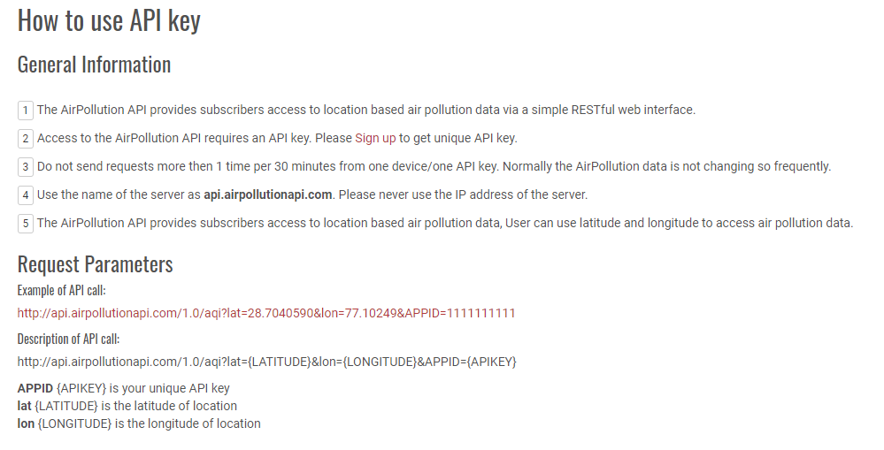

Location:

Using [Google maps](https://www.google.com/maps) find the Latitude and Longitude.

API response:

Using “POSTMAN” software-

Response of API in raw text :

{"status":"success","msg":null,"data":{"text":"Poor","alert":"Poor air quality index in this location. It may cause breathing discomfort to people on prolonged exposure, and discomfort to people with heart disease.","color":"#FF9A00;","value":300,"index":4,"updated":"Tue Nov 10 04:45:00 +0000 2020","temp":"21","content":null,"country":"India","clouds":"description = mist, image = https://airpollutionapi.com/images/icons/50d.png","coordinates":{"latitude":25.302547,"longitude":82.98322},"source":{"name":"CPCB, Ardhali Bazar, Varanasi UPPCB","coordinates":{"latitude":25.3505986,"longitude":82.9083074}},"accuracy":"9.23 Km","dominating":"PM2.5","aqiParams":[{"name":"NO2","value":"30.08 µg/m³, AQI 37","aqi":37,"color":"#79bc6a;","text":"Good","updated":"Tue Nov 10 04:45:00 +0000 2020"},{"name":"O3","value":"13.13 µg/m³, AQI 13","aqi":13,"color":"#79bc6a;","text":"Good","updated":"Tue Nov 10 04:45:00 +0000 2020"},{"name":"PM2.5","value":"144.0 µg/m³, AQI 300","aqi":300,"color":"#A52A2A;","text":"Severe","updated":"Tue Nov 10 04:45:00 +0000 2020"},{"name":"Humidity","value":"68.0 %","aqi":null,"color":null,"text":null,"updated":null},{"name":"Barometric Pressure","value":"1017.0 hPa","aqi":null,"color":null,"text":null,"updated":null},{"name":"Wind Speed","value":" 3.36 m/s","aqi":null,"color":null,"text":null,"updated":null},{"name":"Wind Direction","value":"30.0 degrees","aqi":null,"color":null,"text":null,"updated":null}]}}

Query Parameters:

**Key Value**

Latitude 25.302547

Longitude 82.983220

APPID qsfmma0bkgr296g79ogrhfubg5

Data Used:

1. AQI
2. NO2
3. O3
4. PM2.5
5. Temperature
6. Humidity
7. Wind Speed
8. Wind Direction

Programming:

Python:

Functions-

1. weather_api() – This function is used to receive data from API and extract Data from JSON format.
2. genAirQualityImage () – This function is used to generated Air Quality Image data.

It includes “NO2, O3, Pm2.5”.

1. genAaqi () – This function is used to generate image data of “Max AQI” and “Primary Pollutant”.
2. windImage () – This function is used to generate image data of “Wind Speed and Wind Direction”.
3. temp_hum() – This function is used to generate image data of “Temperature and Humidity”.

GPIO:

Raspberry Pi GPIO pins are used for display Power, Wi-Fi Status, Internet Status.

Pin Configuration:

17 – Wi-Fi – Yellow LED, Flash delay 1 sec.

18 – Internet – Green LED, Flash delay 1 sec.

27 – Power – Red LED

Shell Scripts:

There are two Shell Scripts used in this project.

1. pythonlauncher.sh – This script is used to run python programs.
2. javalauncher.sh – This script is used to run java programs.

Crontab:

There are three crontab commands used in this project.

